SQL Implementation 1 for Online Music Submission Database
by
Virpobe Paireepinart
for
Database Design and Implementation
November 10th, 2009
Texas State University – San Marcos

General Document Layout
This document details the implementation of the SQL part of the project. In this section of the project, the database schema is designed, and the E-R model is refined. Then the E-R model is converted to SQL code, so that the actual database can be created. MySQL was used for this database, on a Linux system. The browser-based website admin tool phpMyAdmin was used to execute queries in the database and view the results.
This document contains several sections:
- The refined E-R diagram
- The SQL that is used to create the tables and populate them with data
- The created table’s structures according to phpMyAdmin
- A list of sample queries and their results, along with descriptions of what the queries do.
These sections are contained in the document in this specific order, and it should be clear where each section begins/ends. Page separators will be placed in the document to make these separations extra clear.

E-R Diagram

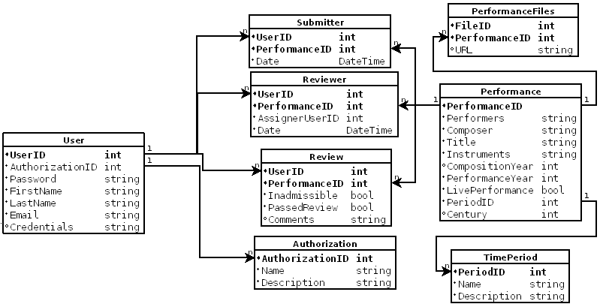

SQL Input Files

The document in the following few pages create a set of tables and populate them with example data. This is so the examples can be executed to display results of sample queries later in the document.

Database Layout

The following few pages are a description by phpMyAdmin of each of the tables in the database, and what data types they are.

